**Coffee Shop Sales**

**Key performance Indicator**

 by kaviyadharshini.k

* SELECT sum(Total_price) as

Total_Revenue from coffee;

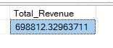

* select count(distinct (transaction_id)) as total_Order

from coffee;



* select round(avg(Total_price),2) as avg_total_price

from coffee;



* select sum(transaction_qty) as Total_product_sold

from coffee;



* select store_location , round(sum(Total_price),2) as total_revenue

from coffee

group by store_location;

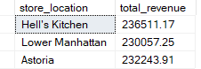

* SELECT DATENAME(DW , transaction_date) as Daily_Trend , count(distinct(transaction_id)) as total_Order

from coffee

group by DATENAME(DW , transaction_date)

order by DATENAME(DW ,

transaction_date) desc;

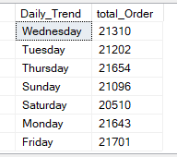

* SELECT DATEPART(hour , Time) as Hourly_Trend , count(distinct(transaction_id)) as total_Order

from coffee

group by DATEPART(hour , Time)

order by DATEPART(hour ,Time) desc;

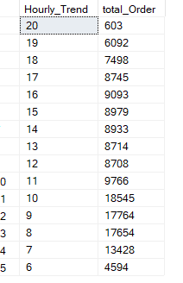

* select MONTH(transaction_date) as Monthly_Trend,

count(distinct(transaction_id)) as

total_Order

from coffee

group by MONTH(transaction_date)

order by MONTH(transaction_date);

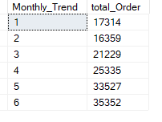

* select product_type , sum(transaction_qty) as total_Order

from coffee

group by product_type

order by sum(transaction_qty) desc;

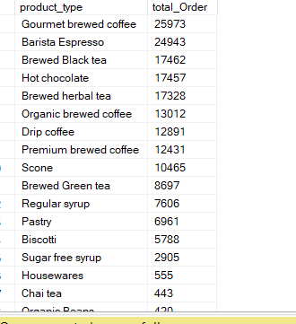

* select size , sum(Total_Price) as total_Price

from coffee

group by size

order by sum(Total_Price) desc;

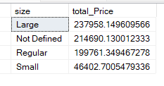

* select top 5 product_type , sum(Total_price) as total_Price

from coffee

group by product_type

order by sum(Total_price) desc;

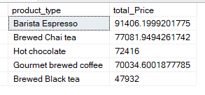

* select top 5 product_type , sum(Total_price) as total_Price

from coffee

group by product_type

order by sum(Total_price) asc;

